**Work instructions for GCP bags inspection and replacement**

**1.0 PURPOSE**

This procedure is developed to cover the safe practices required for safe entry and working in Confined Space and to establish mandatory requirements for protecting personnel from hazards associated in this confined space.

**2.0 SCOPE**

Centralized Confined Space Procedure VL/IMS/VAB/SP44 Y

This procedure applies to confined space: VL/IMS/PID2/BF3/WI/22A

**3.0 RESPONSIBILITIES**

* Operation Head : For day to day activities.
* Shift Incharge : Overall Shift performance.
* Shift Supervisor : To ensure the people are following the procedure.

**4.0 PROCESS DESCRIPTION**

**4.1 DO’S**

1. Workers entering the space shall be trained on confined space and entry procedures & authorized to work in confined spaces.
2. Permit requestor shall prepare the work permit with details of Isolations required and other special permits required. The permit shall be completed in all aspects.
3. Workers entering the space shall be selected and recorded on the work permit as well as in in/out entry book.
4. Workers shall be made aware of possible hazards that may be encountered on that job. Shift wise Toolbox Talk shall be carried out and recorded on the work permit.
5. Appropriate danger signage shall be posted. Ensure area barricading before opening the confined space entry point.
6. Appropriate personal protective equipment shall be selected and issued to affected employees.
7. Gas testing shall be carried out by Authorized Gas tester at defined frequencies and results recorded on work permit and in/out entry book.
8. Standby (Attendant) person has to log down the In/Out entry of all entrants and ensure that entrant should be come out after 30 minutes from confined space for normal jobs.
9. In some cases, In/Out time may be relaxed /extended based on the risk involved in the confined space.
10. Work in confined space may be done in night duty hours also (depending upon the criticality) with prior permission of safety head and operation head.

**4.2 DONT’S**

1. Do not bypass SOP.
2. Don’t enter in GCP silo in presence of CO (it should be Zero).
3. Don’t enter in GCP silo if temp is high (more than 40 degree C)
4. Unauthorized operation or repair of any equipment is a punishable offence.

**4.3 POSSIBLE HAZARDS & MITIGATION MEASURES INSIDE THE CONFINED SPACE**

* **Engulfment hazard**: Engulfment and suffocation in a loose material that is stored in a silo is another hazard that can be encountered in a confined space. GCP silo is having headers, cages with bags inside it, may cause engulfment due to lack of space. Proper inspection of GCP silo, checking and cleaning of dust available on silo platform in this case to mitigate engulfment risk.
* **Oxygen deficiency:** Due to the enclosed nature of the GCP silo there may be a possibility of Oxygen deficiency. Also if hot work is carried out in the GCP silo there may be Oxygen deficiency due to fugitive emissions. Gas testing shall be carried out using Multigas meter before entering the GCP silo. Entry shall only be made if the Oxygen level in the GCP silo is between **19.5% - 23.5%.** If the Oxygen level is less than 19.5%, forced ventilation shall be provided and level ensured between **19.5% - 23.5%.** Frequency of gas testing shall be done once in every two hours and before entering the confined space.
* **Fire & Explosion:** NIL. However test the Lower Explosion Limit using Multigas meter and ensure **Zero level.**
* **Exposure to toxic gases:** There may be a possibility of presence of Carbon Monoxide in the GCP silo. Gas testing shall be carried out before entering the GCP silo. Entry shall only be made if the Carbon Monoxide level in the GCP silo **is Zero PPM**. If the CO level is more than **Zero PPM**, forced ventilation shall be provided and level ensured to be **Zero PPM**.

**4.3 PPE’s & OTHER SAFETY EQUIPMENT REQUIRED:**

* Hand Gloves
* Safety Helmet
* Safety Shoes
* Safety Goggles
* SCBA (if required)
* Life line extending outside with double harness. (If required).
* 24 V DC lamps only inside confined space.

**4.4 ISOLATIONS REQUIRED:**

|  |  |  |
| --- | --- | --- |
| **ENERGY SOURCE** | **HAZARDS PRESENT** | **ISOLATION** |
| **Electrical** | YES | / Inlet and Outlet google valve in closed condition/ Relief valve in open condition by putting off isolators & locking with LOTO. |
| **Mechanical/Kinetic** | NO | NO |
| **Hydraulic** | NO | NO |
| **Pneumatic** | NO | NO |
| **Steam** | NO | NO |
| **Chemical** | CO | 1.Chemical asphyxiates  2.Suffocation |
| **Thermal** | Yes-Temperature above 30 Deg C | 1.Burn Injuries |
| **Radiation** | Mobile phone | 1.Blast |
| **Poor Illumination** | Yes | Use 24 V DC lamps only inside confined space. |

* 1. **Procedure:**
* Work permit to be taken as per required procedure stated in SP44Y.

Before Entering in silo ensure –

1. Electrical shutdown of **Inlet and outlet goggle valve (in closed condition) (Positive isolation acting as blank), ) and relief valve in open condition** by putting off isolators & locking with LOTO.
2. Attendant must ensure proper illumination, if illumination not found ok, he must inform concern electrical person to provide 24 V hand lamp.
3. Take the work permit from HOD or Shift SS, Safety for entering inside the confined space.
4. The workmen (Entrant) who is trained and certified by SUB head and having valid confined space gate pass should perform the activity and he can be replaced(in emergency) only by certified entrant .
5. A standby (attendant) who is trained and certified by SUB head and having valid confined space gate pass should perform the activity and he can be replaced(in emergency) only by certified attendant .
6. Standby person who shall be positioned outside the confined space , must have no other duties other than monitoring people and conditions inside the confined space and coordinating with rescue personnel (he must have contact number of rescue team members) if required.
7. Standby (Attendant) person has to log down the entry details of all Entrants.
8. Check of Internal atmosphere of the space for sufficient oxygen content (19.5% to 23 %) flammable gases and vapors, and the potential for toxic air contaminants before entering into main flue duct. If there is any deviation please do not enter into main flue duct.
9. Check for the presence of Chemical asphyxiates such as Carbon monoxide (CO gas detector).It should be 0 PPM
10. Check inside temperature and it should be is in the tolerable range (25 deg C to 45 Deg C). If the temperature is not within limits then appropriate ventilation to be used.
11. Check any dust due to which visibility is reduced or respiratory tract is irritated.
12. The sign-in and sign-out of all persons entering into silo should be recorded.
13. Ensure isolation of GCP silo by visually checking closure of inlet and outlet shut off valve and goggle valve. Resp – Attendant.

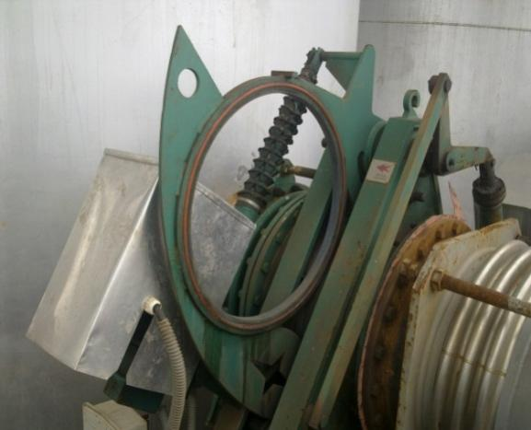

Inlet goggle valve in closed position

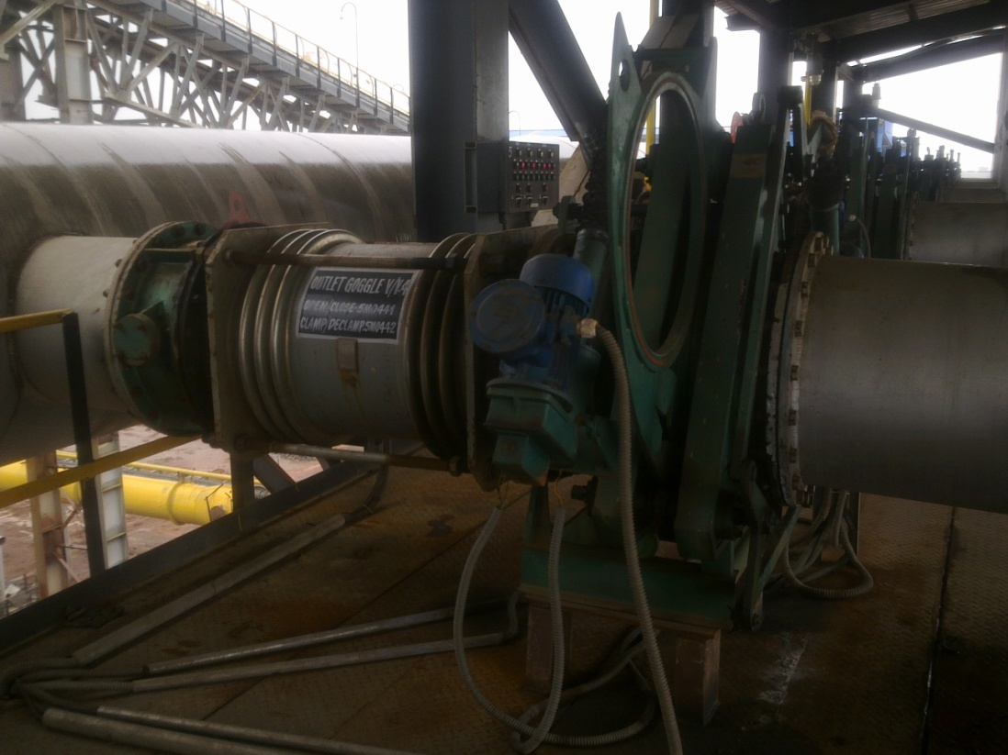

Outlet goggle valve in closed position

Bleeder valve to be opened for purging.

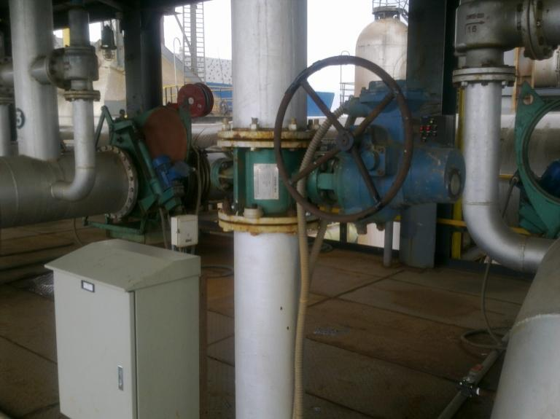

Bleeder/Relief valve needs to be kept open while purging.

1. Nitrogen purging to be done of silo to be cleaned, till CO gas is 0 ppm. This can be checked from a ball valve provided on top of the silo. Responsibility : Operation engg.
2. After CO becomes ZERO ppm close the nitrogen purging line. Remove hose from Nitrogen line and connect to compressed air line. Now start purging with compressed air. Compressed air is required to be purged till oxygen level in the silo is above18 %. Responsibility: Operation engg.
3. Puffing header of the silo in which work is to be carried out has to be isolated before opening the manholes. Close the nitrogen inlet valve to the header and slowly open the header bottom drain valve to de-pressurize & Responsibility: Operation engg.
4. Blanked N2 inlet to puffing header & upper dust unload valve by 3.15mm ms plate.
5. After clearance from operation engg. Open the manhole at bottom and top of silo by loosening the bolts.
6. Install Exhaust fan in front of purging manhole facing towards outside to drag dust partials from silo .

Note - In case silo 1 & 8 manhole needs to be opened then restrict the concerned staircase entry and use foldable working platform for safe working.

**Activities:**

* **Bags replacement**
* **Grating replacement**
* **Canopy fixing**

**Activity 1: Silo bags replacement**

1. Now once all the preparatory activities are completed, take work permit for working in confined space saying silo bags replacement from SS or operation head. Responsibility Authorized Mech Engg.
2. Once all above activities are completed /ensured, identify the bags to be replaced from purging manhole.
3. The bag can be identified by counting the grid from X and Y direction.
4. For replacing bags , workmen needs to enter into the silo from top manhole. Mark the identified bags to be replaced.
5. Remove the bolts of the locking channel above the puffing pipes. Channels are to be placed at the side so that it does not obstruct bag replacement job.
6. Lift the identified cage up to 2.5 meter and unscrew the joint(Every 2m joint is there which can be unscrewed and removed). and then pull out the bag and replace with a new one. Now put back the cage parts.
7. Fix back the puffing pipes and locking channels and fully tighten the bolts.
8. Take clearance from production department before closing the manhole.
9. Remove the installed man cooler.
10. Clean the flange and blind surfaces properly with wire brush. Fix 2 continuous rounds without joint of 16mm graphite asbestos rope in the groove provided on the flange.
11. Tighten the flange bolts diagonally and uniformly till the gap reduces to 7 to 8mm.
12. Remove hose from compressed air purging and fix it to the nitrogen purging line.
13. Soap bubble Leakage test to be carried out at 0.5 kg/cm2 with Nitrogen purging. Nitrogen purging to be carried out with pressure gauge and safety valve in position. To be jointly done by Mechanical and operation engineer. Excess pressure above 1.6 kg/cm2 could result in explosion of vessel. Never exceed testing pressure above 1 kg/cm2.
14. If soap bubbles appear, re-tighten the bolts.
15. Clear electrical shutdown and work permit and hand over to production.

**Activity 2: Grating replacement**

1. Now once all the preparatory activities are completed, take work permit for working in confined space saying grating replacement (hot work) from SS or operation head. Responsibility Authorized Mech Engg.
2. For replacing grating, workmen need to enter into the silo from bottom manhole.
3. Inspect the conditions of grating & replace the damage gratings
4. Take clearance from production department before closing the manhole.
5. Clean the flange and blind surfaces properly with wire brush. Fix 2 continuous rounds without joint of 16mm graphite asbestos rope in the groove provided on the flange.
6. Tighten the flange bolts diagonally and uniformly till the gap reduces to 7 to 8mm.
7. Remove hose from compressed air purging and fix it to the nitrogen purging line.
8. Soap bubble Leakage test to be carried out at 0.5 kg/cm2 with Nitrogen purging. Nitrogen purging to be carried out with pressure gauge and safety valve in position. To be jointly done by Mechanical and operation engineer. Excess pressure above 1.6 kg/cm2 could result in explosion of vessel. Never exceed testing pressure above 1 kg/cm2.
9. If soap bubbles appear, re-tighten the bolts.
10. Clear electrical shutdown and work permit and hand over to production.

**Activity 3: Canopy replacement**

1. Now once all the preparatory activities are completed, take work permit for working in confined space saying canopy fixing (hot work) from SS or operation head. Responsibility Authorized Mech Engg.
2. For replacing canopy, workmen need to enter the silo from bottom manhole.
3. Fix the canopy just above the inlet line & at the bottom of purging manhole with proper support.
4. Ensure that no welding bits or scrap material is not thrown inside the silo
5. Inspect all welding joints.
6. Take clearance from production department before closing the manhole.
7. Clean the flange and blind surfaces properly with wire brush. Fix 2 continuous rounds without joint of 16mm graphite asbestos rope in the groove provided on the flange.
8. Tighten the flange bolts diagonally and uniformly till the gap reduces to 7 to 8mm.
9. Remove hose from compressed air purging and fix it to the nitrogen purging line.
10. Soap bubble Leakage test to be carried out at 0.5 kg/cm2 with Nitrogen purging. Nitrogen purging to be carried out with pressure gauge and safety valve in position. To be jointly done by Mechanical and operation engineer. Excess pressure above 1.6 kg/cm2 could result in explosion of vessel. Never exceed testing pressure above 1 kg/cm2.
11. If soap bubbles appear, re-tighten the bolts.

* Clear electrical shutdown and work permit and hand over to production.

**4.6 RESCUE PLAN:**

**4.6.1 Prior to entry and/or work in the Confined Space:-**

* The permit requestor, permit approver and safety officer will ensure that the on-site rescue plan for the confined space has been completed and that all the rescue equipment identified in the plan is available to affect a rescue in the confined space.
* The permit requestor, permit approver and safety officer will ensure that an adequate number of appropriately trained personnel are available for immediate implementation of the rescue if so required.
* The permit requestor, permit approver and safety officer will ensure that all personnel in the rescue team understand and know their roles and responsibilities and have signed the rescue plan prior to any personnel entering the confined space. Ensure everyone is aware of the evacuation alarm.
* The Stand by person must establish communication with all workers (inside and outside of the confined space) using the means described in the rescue plan.

**4.6.2 On entry and while working in the Confined Space:-**

* The Standby person, who is stationed outside and near the entrance to the confined space as shown in the rescue plan, remains in constant communication with all workers inside the confined space.
* The Standby person must be notified immediately if an entrant recognizes: -
  + Unusual action or behavior.
  + An unexpected hazard
  + An unsafe act
  + Detects a condition prohibited by the permit
  + Rescue equipment for vertical/horizontal retrieval from top/side manhole; to be kept ready with rescue team.
* Personnel must exit the confined space as quickly as possible, when: -
  + An order to evacuate is given by the Standby person
  + An entrant recognizes a sign or symptom of exposure
  + An unacceptable condition arises
  + An evacuation alarm is activated

**4.6.3 In the event of a confined space rescue: -**

* Call security and rescuers at site, explain what is happening and where
* Call Ambulance and fire brigade (if required).
* Call ambulance at site.
* Call first aiders at site.
* Attempt to communicate with the Entrants in the confined space to establish what injuries exist and what conditions exist that may impede the rescue efforts.
* Check the atmospheric conditions to determine if respirators or supplied oxygen are required.
* Ensure that an Attendant is in place outside the entry point to assist the rescue team.
* Rescue team to enter GCP silo from inspection door .
* If any entrant found to be injured, then rescue team can take help of first aider.
* Plan for the Entrant(s) extraction. This may require the use of stretchers, etc.
* Rescuers must ensure the safety of the injured Entrant(s) during the extraction procedure.
* Entrant Once retrieved from confined space, provide any additional first aid required to stabilize the Entrant(s) until an ambulance arrives.
* Secure area and ensure that no one enters the confined space until it has been reassessed and deemed safe to enter.

**4.6.4 Rescue Equipment**

|  |  |  |
| --- | --- | --- |
| **PARTICULARS** | **REQUIRED YES OR NO** | **REMARKS (IF ANY)** |
| Harness | No |  |
| Tripod | No |  |
| Multi Gas Detector | Yes |  |
| Hazardous Chemical Suit | Yes |  |
| First Aid Kit | Yes |  |
| Life / Rescue Line | Yes |  |
| Self-Contained Breathing Apparatus | Yes |  |
| Stretcher | Yes |  |
| Temperature Gun | Yes |  |
| Lux Meter | Yes |  |

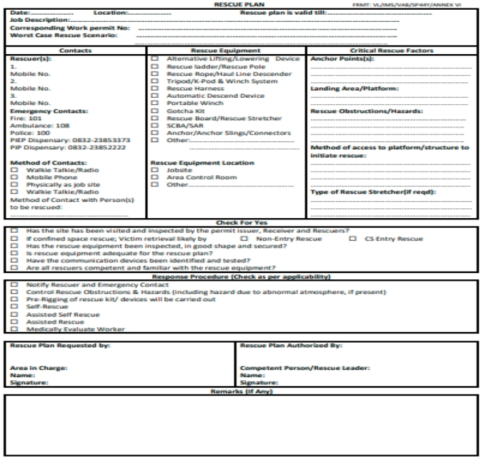

**Amendement Record**

|  |  |  |  |
| --- | --- | --- | --- |
| **Date** | **Manual Section Ref. & Para** | **Brief details of Revision** | **New Rev.** |
|  |  |  |  |
|  |  |  |  |
|  |  |  |  |

|  |  |  |
| --- | --- | --- |
| Prepared By:  Engineer – BF#3 | Reviewed & Issued By:  Management Representative | Approved By:  Head BF#3 |
| Signature: | Signature: | Signature: |
| Review Date: 10.12.2022 | Review Date: 10.12.2022 | Review Date: 10.12.2022 |